

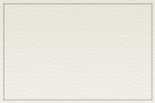
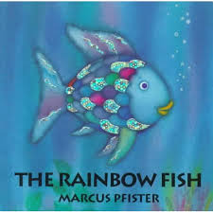
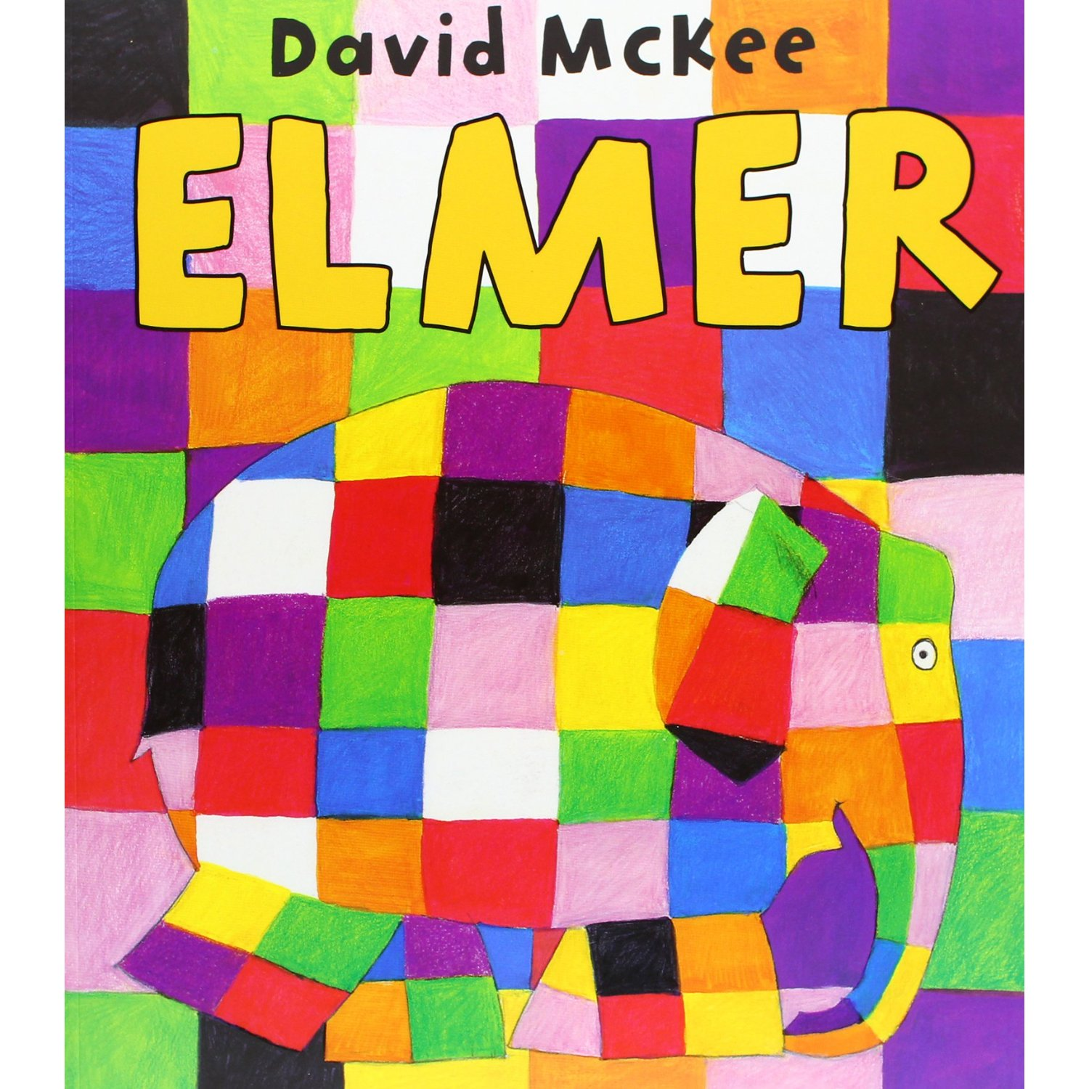
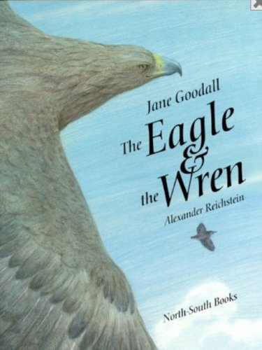
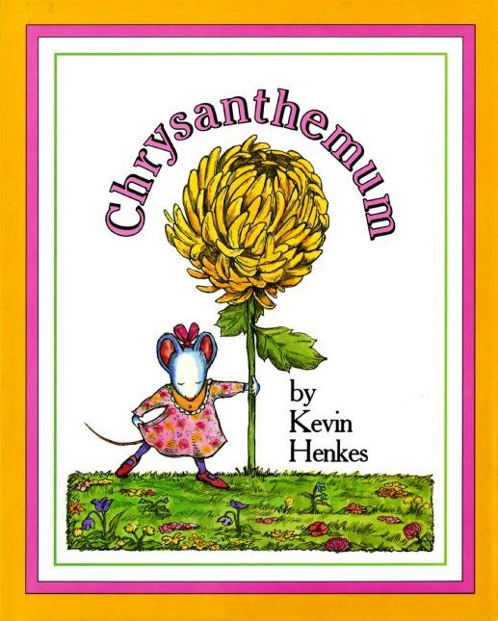
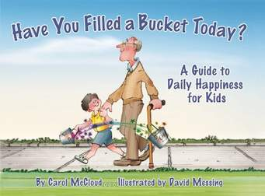
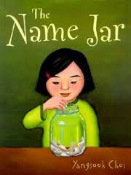
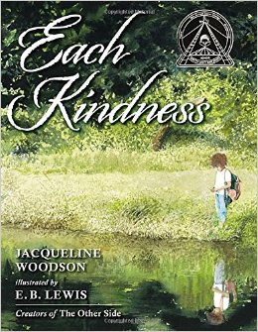
Important!
New School Policy...
If sending in a birthday treat, all items must be store bought and packaged. That means no more home made treats.

Also, please remember that a letter was sent concerning a peanut allergy in our classroom. Let me know if you have any questions.
Mr. Consaul’s Class News
10/20/15
We have had an excellent start to the school year! Your children have been a delight to work with each day. I’m looking forward to our year together.
Ask your child about: *Chance Tickets
*Our 2 Class Rules
~Homework - read 20 minutes a night and write a response! These are a few of the favorites we enjoyed this week. Ask your child about the characters and what happened in the stories. How do these books connect to our rules? We also have math homework on Mon. -Thurs. Please ask for your childs homework folder to see work that we have been doing

Have a great weekend!
Mrs. Consaul

